Task 1: What is SDLC?

SDLC is as structured process of software development that helps in from initial planning till final maintenance.

Task 2: Why SDLC?

With SDLC we achieve quality, reliability, cost effectiveness, meeting user needs and also reduce risks with project management.

Task 3: Steps of SDLC

SDLC models bare minimum have planning and requirement verification, design, development, testing, deployment , maintenance

Task 4: Models of SDLC, with description

**Waterfall Model:**This is a step-by-step approach where each phase—like requirements gathering, design, implementation, testing, deployment, and maintenance—must be finished before moving on to the next. It’s highly structured, which can be helpful for planning, but it doesn't handle changes very well once the process is underway.

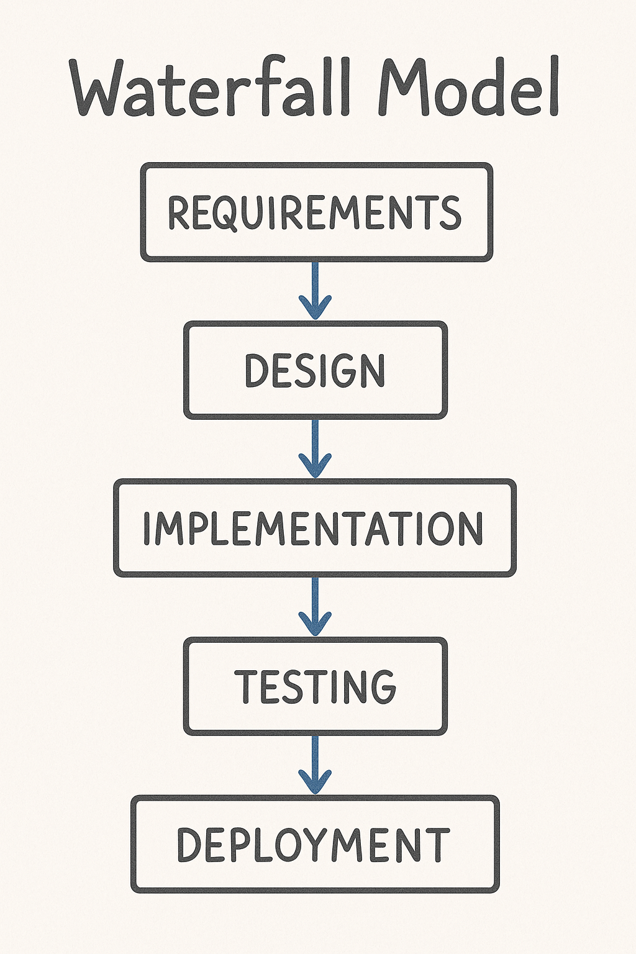

**V-Model:**Also called the Verification and Validation model, the V-Model aligns each development stage with a corresponding testing phase. The idea is to build in quality from the start by testing at every level. It’s methodical and puts a strong focus on catching issues early through parallel development and testing.

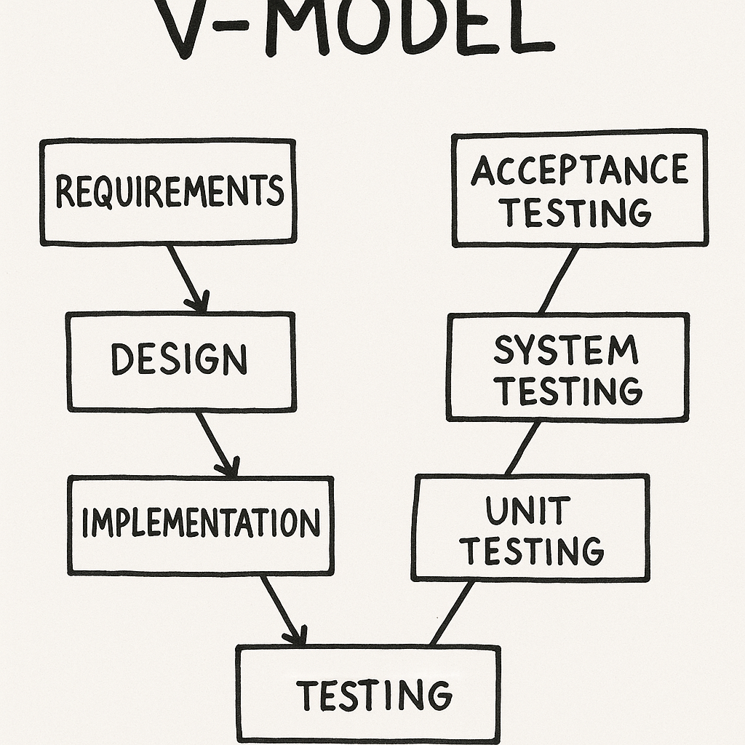

**Iterative Model:**In this approach, software is built and refined in small chunks or iterations. Each iteration results in a working version of the product, allowing teams to gather feedback early and make improvements as they go. It’s a flexible way to develop software, especially when the end goals might evolved

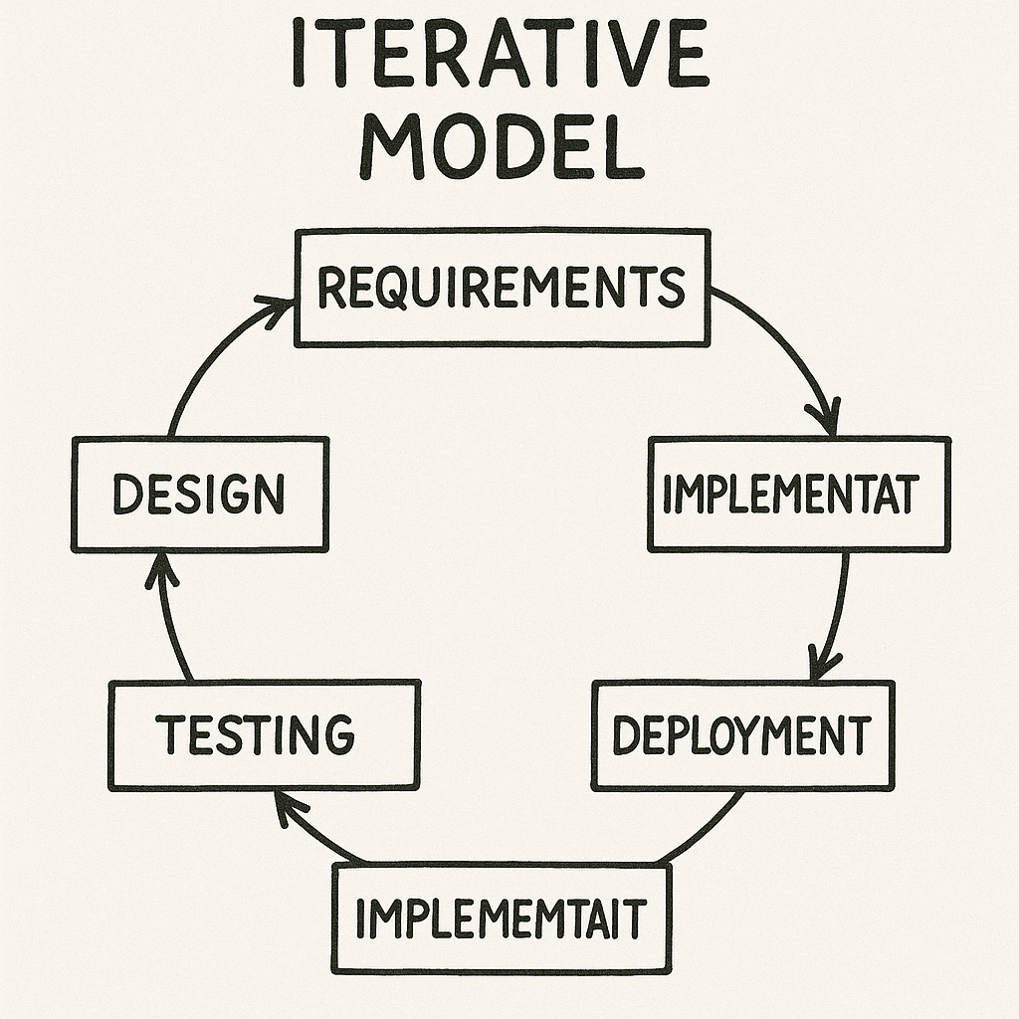

**Spiral Model:**This model mixes elements of the Waterfall and Iterative models but adds a strong focus on risk management. Each cycle involves identifying potential risks, evaluating them, and addressing them before continuing. It’s especially useful for large, complex, or high-risk projects.

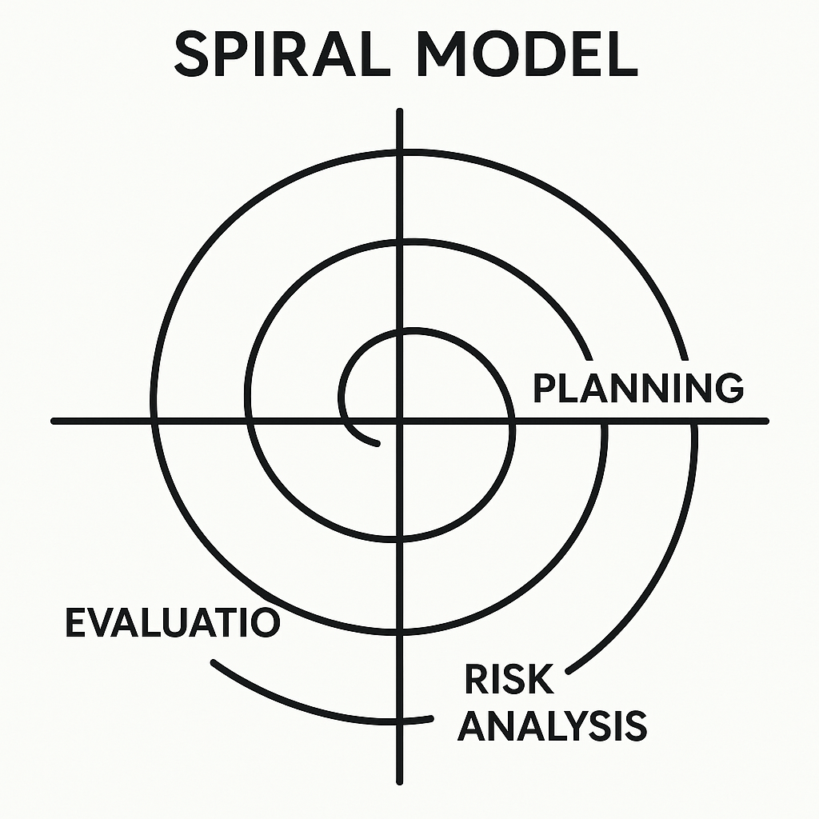

**Agile Model:**Agile is more of a mindset than a single process. It emphasizes quick, incremental deliveries of working software, close collaboration with stakeholders, and the ability to adapt to change. Through regular feedback and ongoing improvements, Agile helps teams stay aligned with user needs and project goals.

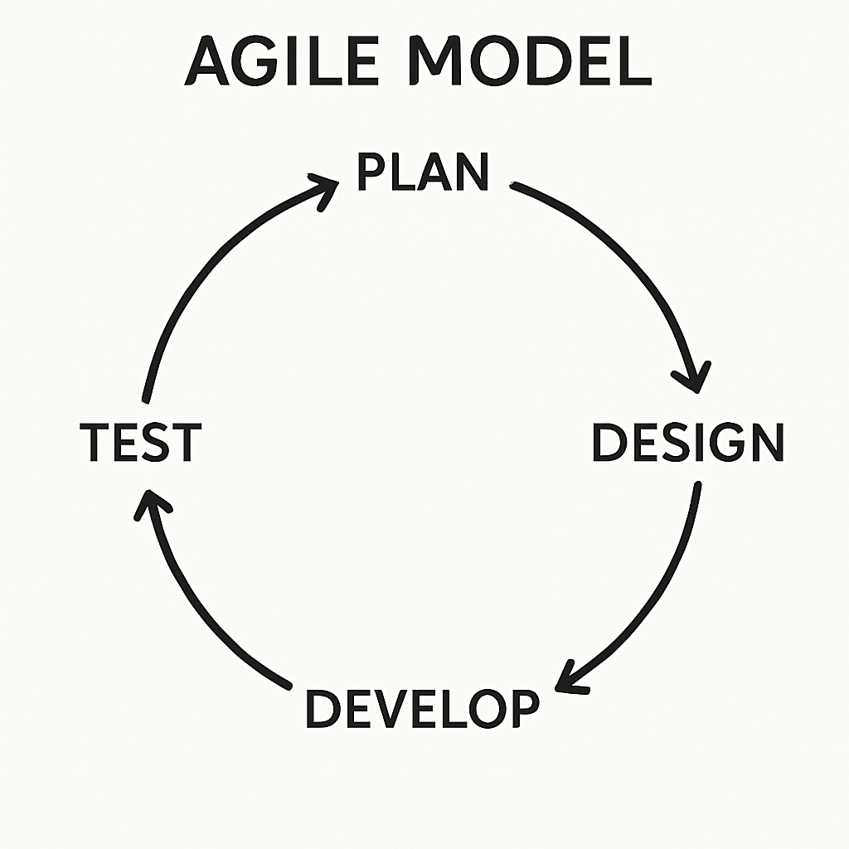

Task 5 : What are different networks?

PAN - Personal Area Network ex bluetooth, NFC

LAN - Local area network, within an organisation or building

WAN - Wide area network ,Coers large area ex. Internet

WLAN - Wireless LAN

Task 6: Types of servers?

DNS Server. - resolves domain name into ip

FTP server - File Transfer server using FTP protocol

Mail server - Handles sending, receiving, and storing emails

Application server - runs applications by executing server side code of the application ex: Apache Tomcat

Database Server - Stores and manages databases

Web Server : Web App hosting ex nginx responsible for responding the client with the contents / response

Task 8: what is TCP and UDP? What is the difference?

TCP and UDP are both transport layer protocols, which transfers the data between the two networks

TCP is connection oriented protocol that provides reliable , ordered and error checking delivery of stream of bytes between applications running on hosts communicating using an IP network

Used in email, web browsing, remote access

UDP is connectionless, faster than TCP, but not reliable, or error checked

Less overhead,

Used in DNS, games, VOIP , streaming

Task 9: What do you know about mac address ? What is the difference between Mac address and IP address.

A MAC address is a unique identifier assigned to a network interface card (NIC) for use in data communication on a local network.It is used at the Data Link Layer of the OSI model.

00:14:22:01:23:45 ex Mac address

OUI (Organizationally Unique Identifier): First 3 bytes → identifies the manufacturer.

1.

MAC Address identifies a device on a local network (LAN).

IP Address identifies a device on a global network (Internet).

2.MAC Address is a physical, permanent address into the hardware.

IP Address is a logical, changeable address assigned by a network.

3.

Only visible in LAN MAC , and IP is visible to WAN or Web

Task 10:

OSI model?

Open system interconnection

Osi model is conceptual and standardised framework to understand the communication between the 2 or more networks.

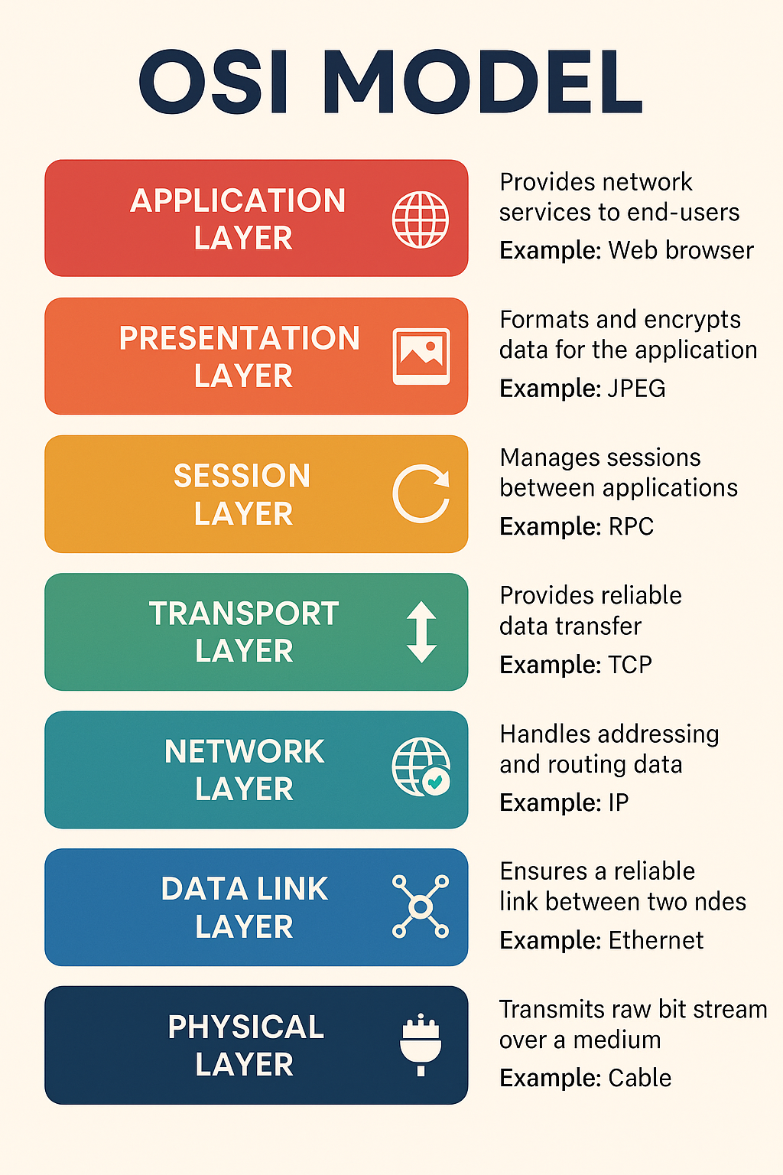

7 layers of OSI

7. Application Layer :It’s where network services are accessed by end-user applications like web browsers, email clients, etc.

Ex : HTTP, SMTP, SSH

6. Presentation Layer : formats, encrypts, and compresses data so it can be properly understood, secured, and efficiently transmitted between devices.

5. Session layer : It establishes, maintains, and terminates connections, ensuring that data exchange is organized and synchronized.

4.Transport layer : is responsible for end-to-end communication between devices.

Ex are TCP , UDP

3. Network Layer : The Network Layer is responsible for determining how data is routed and delivered from the source device to the destination device across multiple networks. It plays a critical role in logical addressing, path selection (routing), and packet forwarding.

2. Data Link : Handles node-to-node data transfer and error detection/correction, Works with MAC addresses and switches

1. Physical Link : Deals with the physical connection (cables, switches, signals, bus), Transmits raw bitstreams over the physical medium

Task 11: IPv4

IPv4 is 4th version of the Internet Protocol, used to identify devices on a network using a numerical address.

### Key Features:

* **Address Format:** 32-bit number (written as four decimal numbers)  
  + Example: 192.168.1.1
* **Total Addresses:** Around 4.3 billion (2³²)
* **Used for:** Routing data packets between devices on the internet.

Each number is called an **octet** (8 bits)

Range: 0 to 255 per octet

### **\* Types of IPv4 Addresses:**

* **Public IP:** Globally unique (used on the internet)
* **Private IP:** Local use only (like 192.168.x.x)
* **Static IP:** Doesn’t change
* **Dynamic IP:** Assigned by DHCP, changes over time

IPv4 addresses are organized into five classes (A, B, C, D, and E) based on the first octet, which determines the size of the network. Classes A, B, and C are used for unicast addressing, while Class D is for multicast, and Class E is reserved for experimental purposes

| **Class** | **Starting Bits** | **Range (1st Octet)** | **Purpose** | **Default Subnet Mask** |
| --- | --- | --- | --- | --- |
| **A** | 0 | 1 – 126 | Large networks | 255.0.0.0 |
| **B** | 10 | 128 – 191 | Medium-sized networks | 255.255.0.0 |
| **C** | 110 | 192 – 223 | Small networks | 255.255.255.0 |
| **D** | 1110 | 224 – 239 | Multicasting (not hosts) | *No subnet mask* |
| **E** | 1111 | 240 – 255 | Experimental (reserved) | *Not for public use* |

Task 12: What is use of VPN?

1. Enhanced Privacy and Anonymity by hiding your IP address and online activity from ISPs, hackers, and websites.
2. VPNs encrypt all traffic between your device and the internet.
3. Remote Access to Office Networks
4. Lets us bypass censorship or content restrictions in certain countries.

Task 13: Types of VPN

Access VPN : Connects a user to a private network (like office network) from a remote location.

Site-to-Site VPN : Connects two or more networks in different locations.  
 Used by Large organizations to link multiple branch offices securely.  
 Example**:** Headquarters and branch office sharing internal data over the internet.

Intranet VPN **:** An Intranet VPN is used to securely connect different branches or offices of the same organization over the internet, as if they were on the same local network (intranet).

Type of Site-to-site vpn

Extranet VPN **:** An Extranet VPN allows a company to securely connect with external partners, such as suppliers, vendors, or clients, over the internet.

A VPN that connects **two or more different organizations**.

Task 14: Different types of network topology

Types of Network Topology:

1. Bus – All devices share one cable.
2. Star – Devices connect to a central hub.
3. Ring – Devices form a circular loop.
4. Mesh – Every device connects to every other.
5. Tree – Hierarchical structure combining bus and star.
6. Hybrid – Combination of two or more topologies.

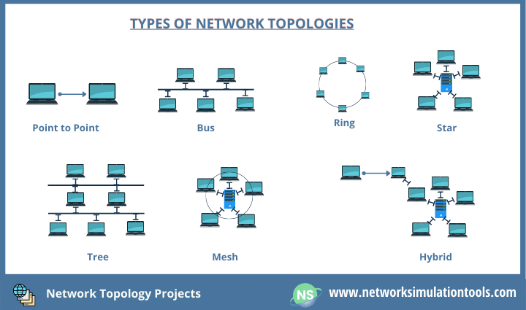

Task 15:

Difference between Router and Gateway?

| **Feature** | **Router** | **Gateway** |
| --- | --- | --- |
| **Function** | Connects **multiple networks** of the **same type** | Connects networks using **different protocols** |
| **Use** | Directs data between similar networks (e.g., LANs) | Acts as an entry/exit point between networks |
| **Layer** | Works mostly at **Network Layer (Layer 3)** | Can work at **any layer** (often Network or above) |
| **Example** | Home router connecting devices to the internet | Gateway connecting an internal network to a cloud service |

### **In Short:**

* A **router** is like a **traffic controller** inside a city.
* A **gateway** is like a **border checkpoint** between two countries using different rules.

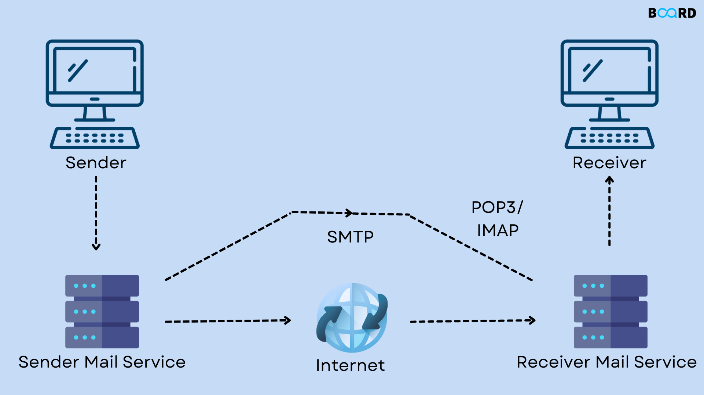

Task 20:

DIfference between OSI and TCP/IP

The OSI model and the TCP/IP model are two conceptual frameworks used to understand and implement networking protocols. Here's a clear comparison of the two:

| **Aspect** | **OSI Model** | **TCP/IP Model** |
| --- | --- | --- |
| **Full Form** | Open Systems Interconnection | Transmission Control Protocol / Internet Protocol |
| **Number of Layers** | 7 Layers | 4 Layers |
| **Layer Names** | Application, Presentation, Session, Transport, Network, Data Link, Physical | Application, Transport, Internet, Network Interface |
| **Development** | Developed by ISO as a theoretical model | Developed by the U.S. DoD based on real-world protocols |
| **Approach** | Reference model | Implementation model |
| **Protocol Dependency** | Protocol-independent | Protocol-specific (centered around TCP/IP) |
| **Usage** | Mainly used for teaching and reference | Used in actual network communication (Internet) |
| **Layer Interaction** | Strict separation of layers | Loosely defined layer boundaries |
| **Examples of Protocols** | HTTP, FTP, TCP, IP, Ethernet | HTTP, TCP, IP, Ethernet |

+----------------------------+

| Application Layer |

| (HTTP, FTP, DNS, SMTP) |

+----------------------------+

| Transport Layer |

| (TCP, UDP) |

+----------------------------+

| Internet Layer |

| (IP, ICMP) |

+----------------------------+

| Network Interface Layer |

| (Ethernet, Wi-Fi, ARP) |

+----------------------------+

Task 21:

**HLD (High-Level Design)**: Describes the system architecture, major components, and data flow between them. It's a bird's-eye view for stakeholders and architects.

**LLD (Low-Level Design)**: Provides detailed design of individual modules, algorithms, and interfaces. It's meant for developers to implement the actual code.

Task 22:

An **SRS (Software Requirements Specification)** document defines **what** a software system should do and **how** it is expected to perform. It is a formal document that outlines **functional**, **non-functional**, and **technical** requirements for developers, testers, and stakeholders.

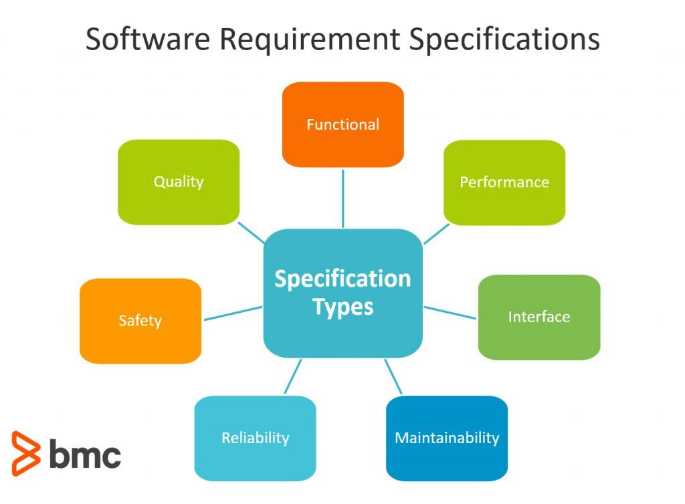

1.

A feasibility study using the SDLC model is conducted to

determine whether or not the project is technically possible

determine whether the proposal is financially viable

Both a and b

None of the above

2.

A well-documented life cycle model aids in the detection of what during the development phase?

Inconsistencies

Redundancies

Omission

All of the above

3.

How many lines of code does the Build & Fix Model suit for programming exercises?

100-200

300-400

600-700

Above 800+

4.

In which life cycle does regression testing play a significant role?

Waterfall model

V model

Iterative model

All of the above

5.

What determines if the project should go forward?

feasibility assessment

opportunity identification

system evaluation

program specification

6.

What is the most significant disadvantage of employing the RAD Model?

Developers/designers that are highly specialized and skilled are required.

Component reusability is improved.

Encourages client/customer input.

Increases component reusability.

7.

Which of the following developmental models is incremental?

Prototyping, V model, Agile

Prototyping, RAD, Agile, RUP

Prototyping, V model, RAD, Agile, RUP

All of the above

8.

Which of the following is an Agile development characteristic?

Shared code ownership

Test-Driven Development

Implement the simplest solution to meet today's problem

Continual feedback from customer

All of the above

9.

Which of the following steps in the SDLC framework are valid?

Requirement Gathering

Software Design

System Analysis

All of the above

10.

Who is in charge of system development, staffing, budgeting, and reporting, as well as ensuring that deadlines are met?

Project managers

Network engineers

Graphic designers

Systems analysts